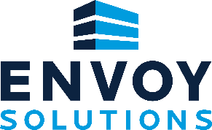
“The Envoy Solutions Way” Values Recognition Nomination Form

Employee Nominee ___________________________ (print first and last name of employee being nominated)
Employee Nominee Position ____________________________
Employee Nominee Business Unit/Branch __________________________

Envoy Value(s) Being Recognized (Circle as appropriate)
Integrity Respect Agility Accountability Social Responsibility Growth Orientation Collaboration
Describe the reason for the nomination below: (attach additional documentation as desired)

Nominated By ___________________________ (print first and last name)
Contact Information ________________________________________ (email and phone number of person making the nomination)
Submit nominees to Dave Aldridge Vice President Human Resources daldridge@na.com

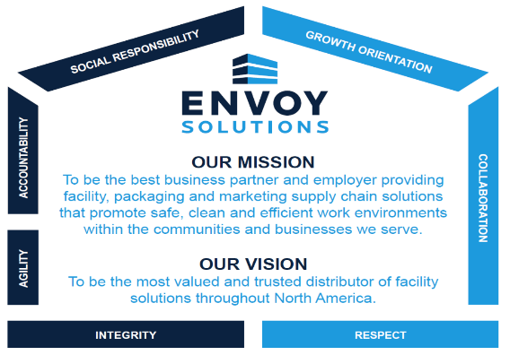
Envoy Solutions Values:
Integrity
Integrity gives meaning to our company’s voice because our employees, customers, and suppliers trust what we say. We achieve the highest level of integrity by following through on our commitments, creating purpose across our organization, and making positive contributions to the communities we serve.
Respect
We strongly believe every employee, customer, and supplier-partner deserves the utmost respect, regardless of title or position. We respect each other by embracing diversity, treating everyone with dignity, and including a wide variety of perspectives in our company communications and initiatives.
Collaboration
Our business model is based on building partnerships across the country and leveraging the strengths from each of our companies to become one stronger organization. We are at our best when we grow our national platform by collaborating across teams, business units, and other key functions. Our future success is dependent upon our ability to continue working together efficiently and effectively.
Growth Orientation
Our company’s growth fuels new opportunities for our employees, customers, and supplier-partners. As we become a larger organization, we can further invest in our business, provide more resources to our employees, and have a greater impact on the communities we serve. We are focused on growth both internally and externally. From an external perspective, we grow by increasing our sales volume, expanding the services and solutions we provide our customers, and becoming a prominent provider in all major markets. When we grow internally, we can significantly expand the perks and benefits we offer our employees, expand our job roles and functions, thus providing more robust career development which benefits team members both personally and professionally.
Social Responsibility
We strive to have a positive impact on the world around us, which means we need to rally around important causes and do our part in the community. A sense of social responsibility creates purpose for our associates, it enhances our public image, and makes us proud of our company. We’ve taken significant steps to be good corporate citizens by engaging our employees for community events, promoting our environmentally friendly products, and communicating the importance of social responsibility in the company newsletter and other Envoy Solutions platforms.
Accountability
Our organization’s success depends upon each of us carrying out our job duties to the best of our abilities. We have high standards for accountability for all Envoy Solutions associates, from warehouse workers to the office staff to the Executive Leadership Team. We are expected to complete our assigned tasks, be goal-oriented, and follow through on our commitments to each other, to our suppliers, and to our customers.

Agility
Agility is essential for our business to respond effectively to unpredictable and uncontrollable factors in today’s world, and to make the necessary adjustments to changing market conditions. As our company continues to experience growth and development, we need to be agile to adjust to a dynamic work environment and to quickly respond to the changing needs of our customers and supplier partners.

